[](https://ds24-troick.educhel.ru/uploads/53500/53473/section/1846308/1-7.jpg?1724902351)[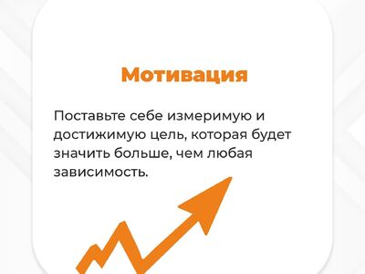](https://ds24-troick.educhel.ru/uploads/53500/53473/section/1846308/2-7.jpg?1724902351)

[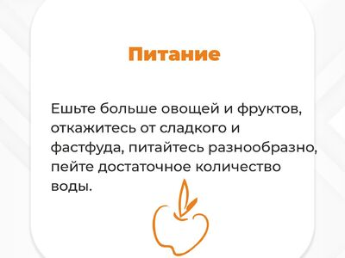](https://ds24-troick.educhel.ru/uploads/53500/53473/section/1846308/3-6.jpg?1724902350)

[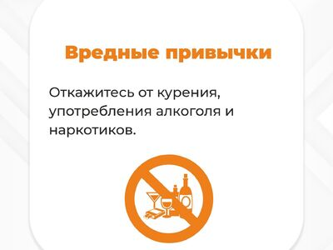](https://ds24-troick.educhel.ru/uploads/53500/53473/section/1846308/4-6.jpg?1724902350)

[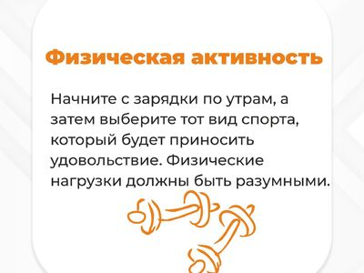](https://ds24-troick.educhel.ru/uploads/53500/53473/section/1846308/5-5.jpg?1724902350)

[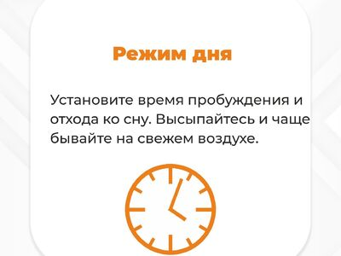](https://ds24-troick.educhel.ru/uploads/53500/53473/section/1846308/6-5.jpg?1724902349)

[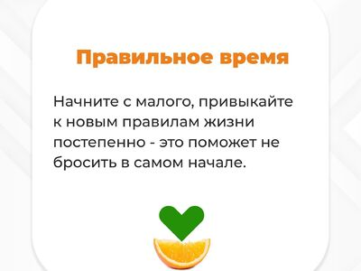](https://ds24-troick.educhel.ru/uploads/53500/53473/section/1846308/7-5.jpg?1724902349)